T.C.
SAMSUN UNIVERSITY
ENGINEERING FACULTY
INDUSTRIAL ENGINEERING DEPARTMENT

ENDM204 WORK STUDY AND ERGONOMICS

EXPERIMENT REPORT

Prepared by

Assist. Prof. Dr. Aycan PEKPAZAR
Ress. Ass. Ebru PEKEL ÖZMEN

SAMSUN UNIVERSITY
ENGINEERING FACULTY
INDUSTRIAL ENGINEERING DEPARTMENT

PEGBOARD TEST EXPERIMENT REPORT

The Purpose of the Experiment
As a simulation of the industrial environment, it is the assessment of fine motor function of the hand by attaching the commonly used pin, washer and nut on a perforated board in the field.

The Device to Use
The Purdue Pegboard Test was first developed by Joseph Tiffin, Ph.D., an Industrial Psychologist at Purdue University in 1948. Since that time, this device has been used extensively to aid in the selection of employees for jobs that require fine and gross motor dexterity and coordination. It measures gross movements of hands, fingers and arms, and fingertip dexterity as necessary in assembly tasks.

The Purdue Pegboard can be used for many testing applications, such as Physical Therapy, Occupational Therapy, Vocational Evaluation, and Pre-employment Screening. Other applications for the test can be found by doing a bibliography search.

The pegboard comes complete with pins, collars and washers, as well as an examiner's manual.

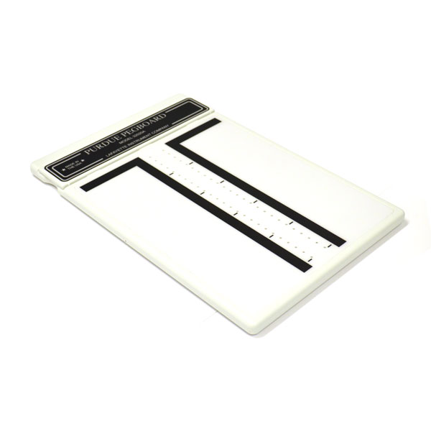
Figure 1. Purdue Pegboard Test Device

EXPERIMENT
The volunteer should be comfortably seated at the testing table directly in front of the Purdue Pegboard, which is placed on the table with the row of cups (Under the nameplate) at the top of the board. The far right and far left cups should have 25 pins in each to equal a total of 50 pins. For right-handed subjects, the cup to the left of centre should have 40 washers. If the subject is left-handed, the collar and washer locations should be on the reverse side of centre. The following directions are for single subject testing and should be appropriately modified for group testing.

- Right hand (30 seconds): Clients use their right hand to place as many pins as possible down on the row within 30 seconds.
- Left hand (30 seconds): Clients use their left hand to place as many pins as possible down on the row within 30 seconds.
- Both hands (30 seconds): Clients use both hands simultaneously to place as many pins as possible down both rows.
- Right + Left + Both hands: *Please note that this is not an actual test, it is a mathematical sum calculation of the above scores.
- Assembly (60 seconds): Clients use both hands simultaneously while assembling pins, washers, and collars.
The testing should commence in the order outlined above unless the volunteer is left-handed.

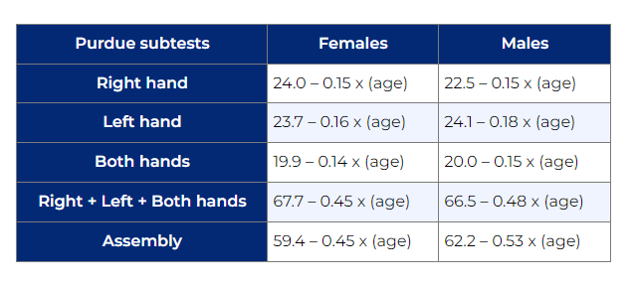
Figure 2. Scaling Formulas

Example: The expected score for an 80-year-old woman on the right hand task is: 24.0 – (0.15 x 80) = 12.

Practice:
Enter the volunteer's points in the following table and compare them to the normal ranges in Figure 2.

Right Hands
Left Hands
Both Hands
Right+Left+Both Hands
Assembly

References:
Ashford, S., Slade, M., Malaprade, F., Turner-Stokes, L. (2008). Evaluation of functional outcome measures for the hemiparetic upper limb: A systematic review. Journal of Rehabilitation Medicine, 40, 787-795
Buddenberg, L.A. & Davis, C. (1999). Test-retest reliability of the Purdue Pegboard Test. The American Journal of Occupational Therapy, 54(5), 555-558
Costa, L.D., Vaughan, H.G., Levita, E. & Farber, N. (1963). Purdue Pegboard as a predictor of the presence and laterality of cerebral lesions. Journal of Consulting Psychology, 27(2), 133-137
Desrosiers, J., Hebert, R, Bravo, G. and Dutil, E. (1995). The Purdue Pegboard Test: Normative data for people aged 60 and over. Disability and Rehabilitation, 17(5), 217-224

